**MS SQL QUERIES**

**COFFEE SHOP SALES SQL PROJECT**

I enhanced each category with deeper, more complex SQL queries that will be analysed the **Coffee Shop Sales** dataset in-depth. Here’s what I did for each level:

**Basic Level**

I added foundational insights that go beyond simple retrieval, including distinct counts, conditional filtering, and basic arithmetic on columns.

**Intermediate Level**

I added advanced filtering, grouping with multiple conditions, conditional aggregations, and ranking functions for detailed insights.

**Advanced Level**

These involve complex joins, window functions, CTEs (Common Table Expressions), and subqueries for richer, layered analysis.

**Basic Level** **Queries:**

1. **Total DAILY SALES, TOTAL QUANTITY and TOTAL ORDERS.**

SELECT

CONCAT(ROUND(SUM(unit_price * transaction_qty) / 1000, 1),'K') AS total_sales,

CONCAT(ROUND(COUNT(transaction_id) / 1000, 1),'K') AS total_orders,

CONCAT(ROUND(SUM(transaction_qty) / 1000, 1),'K') AS total_quantity_sold

FROM Transactions

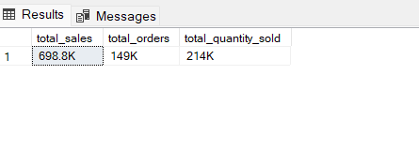

**Insight**: This query helps to find the KPI of Sales, Quantity, Orders .

1. **Retrieve the number of unique products sold per store.**

SELECT store_id,

COUNT(DISTINCT product_id) AS unique_products_sold

FROM Transactions

GROUP BY store_id;

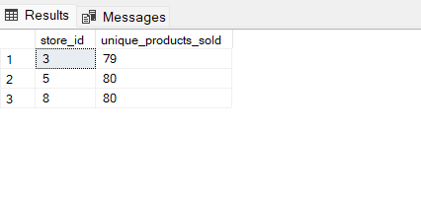

**Insight**: This query helps to understand the variety of products sold at each store.

1. **Calculate total revenue per transaction.**

SELECT transaction_id,

transaction_qty * unit_price AS transaction_revenue

FROM Transactions;

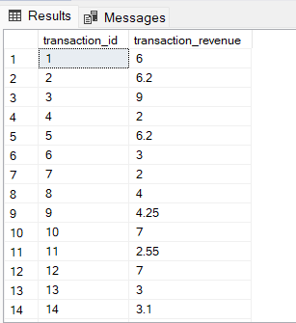

**Insight:** This provides revenue at a per-transaction level, useful for calculating averages or trends.

1. **List transactions where the unit price is above the average price of all products.**

SELECT *

FROM Transactions

WHERE unit_price > (SELECT AVG(unit_price) FROM Transactions);

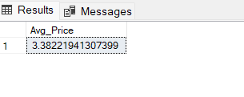

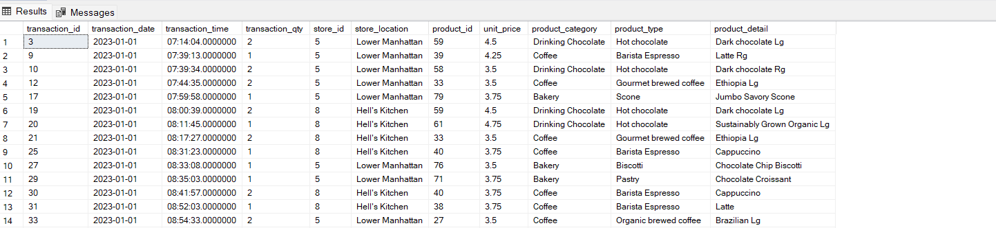

**Insight:** Identifies transactions involving premium-priced products, useful for premium segment analysis.

1. **Count the number of transactions per hour.**

SELECT DATEPART(HOUR, transaction_time) AS hour,

COUNT(transaction_id) AS transactions_count

FROM Transactions

GROUP BY DATEPART(HOUR, transaction_time)

ORDER BY hour;

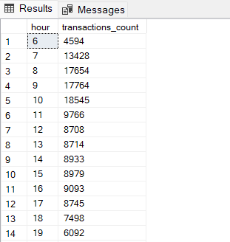

**Insight:** Helps identify hourly transaction patterns, indicating peak and off-peak times.

**Intermediate Level Queries:**

1. **Calculate total and average sales for each product category by month.**

SELECT DATEPART(YEAR, transaction_date) AS year,

DATEPART(MONTH, transaction_date) AS month,

product_category,

-- Count(product_category),

SUM(transaction_qty * unit_price) AS total_sales,

AVG(transaction_qty * unit_price) AS avg_sales

FROM Transactions

GROUP BY DATEPART(YEAR, transaction_date), DATEPART(MONTH, transaction_date), product_category

ORDER BY DATEPART(YEAR, transaction_date), DATEPART(MONTH, transaction_date), product_category;

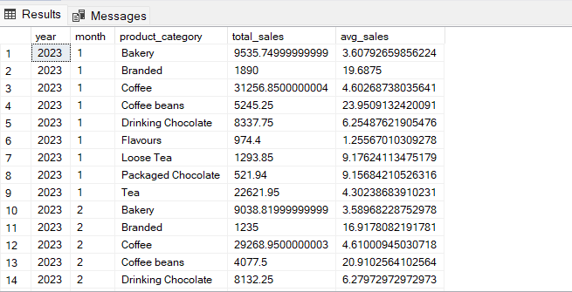

**Insight:** Tracks monthly performance at a category level, helping to spot trends in product sales.

1. **Identify the top 3 best-selling products within each category based on quantity.**

SELECT Top 3 product_category,

product_id,

product_detail,

product_type,

SUM(transaction_qty) AS total_quantity_sold

FROM Transactions

GROUP BY product_category

,product_id

, product_detail,product_type

ORDER BY total_quantity_sold DESC

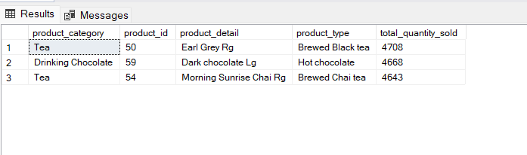

**Insight:** Reveals the most popular products per category, which is useful for inventory and promotional planning.

1. **Calculate revenue generated by each store location for a given quarter (e.g., Q1 of 2023).**

SELECT store_location,

Round(SUM(transaction_qty * unit_price),1) AS total_revenue

FROM Transactions

WHERE transaction_date BETWEEN '2023-01-01' AND '2023-03-31'

GROUP BY store_location

ORDER BY total_revenue DESC;

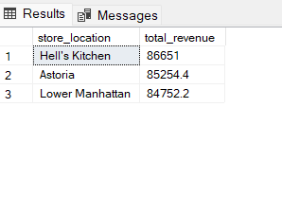

**Insight**: Provides a regional breakdown of revenue for specific timeframes, highlighting top-performing stores.

1. **Rank all products by sales within each store.**

SELECT store_id,

product_id,

product_detail,

SUM(transaction_qty * unit_price) AS total_sales,

RANK() OVER (PARTITION BY store_id ORDER BY SUM(transaction_qty * unit_price) DESC) AS product_rank

FROM Transactions

where store_id = 3

GROUP BY store_id, product_id, product_detail;

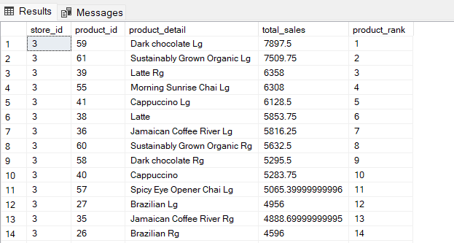

**Insight:** Ranks products in terms of sales within each store, showing which products perform best at a local level.

1. **Get the percentage share of each product category in total sales.**

SELECT product_category,

SUM(transaction_qty * unit_price) AS category_sales,

ROUND((SUM(transaction_qty * unit_price) / (SELECT SUM(transaction_qty * unit_price) FROM Transactions) * 100), 2) AS sales_percentage

FROM Transactions

GROUP BY product_category

ORDER BY sales_percentage DESC;

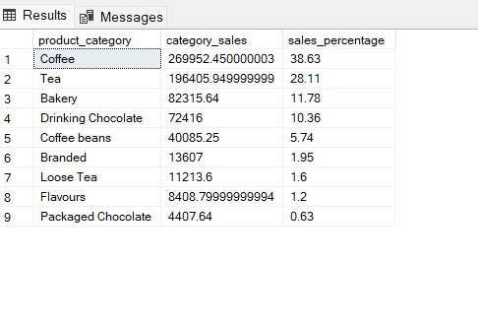

**Insight:** Shows how much each product category contributes to total revenue.

**Advanced Level Queries:**

1. **Determine each store’s peak sales hour.**

WITH hourly_sales AS (

SELECT store_id,

DATEPART(HOUR,transaction_time) AS hour,

SUM(transaction_qty * unit_price) AS sales

FROM Transactions

GROUP BY store_id, DATEPART(HOUR,transaction_time)

)

SELECT store_id,

hour,

MAX(sales) AS peak_sales

FROM hourly_sales

GROUP BY store_id, hour

ORDER BY store_id, hour desc;

**Insight:** Identifies peak sales hour for each store, which is valuable for staffing and promotional strategies.

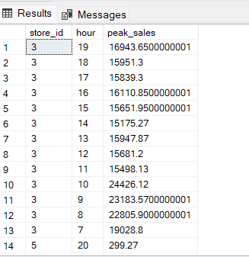

1. **Calculate the average time between transactions for each store.**

WITH transaction_diffs AS (

SELECT store_id,

DATEDIFF(SECOND, LAG(transaction_time) OVER (PARTITION BY store_id ORDER BY transaction_time), transaction_time) AS time_diff

FROM Transactions

)

SELECT store_id,

AVG(time_diff) AS avg_time_between_transactions

FROM transaction_diffs

WHERE time_diff IS NOT NULL

GROUP BY store_id;

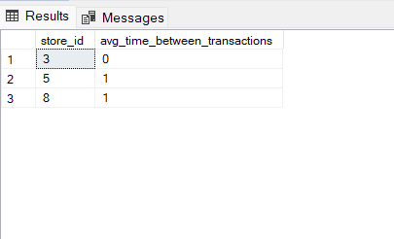

**Insight:** Measures transaction frequency at each store, giving insight into customer traffic.

1. **List stores with above-average sales performance for a specified period.**

WITH avg_sales AS (

SELECT AVG(transaction_qty * unit_price) AS average_sales

FROM Transactions

WHERE transaction_date BETWEEN '2023-04-01' AND '2023-06-30'

)

SELECT t.store_id,

t.store_location,

SUM(t.transaction_qty * t.unit_price) AS total_sales

FROM Transactions t

WHERE t.transaction_date BETWEEN '2023-04-01' AND '2023-06-30'

GROUP BY t.store_id, t.store_location

HAVING SUM(t.transaction_qty * t.unit_price) > (

SELECT average_sales

FROM avg_sales

);

-- Another way using CROSS JOIN:

WITH avg_sales AS (

SELECT AVG(transaction_qty * unit_price) AS average_sales

FROM Transactions

WHERE transaction_date BETWEEN '2023-04-01' AND '2023-06-30'

)

SELECT t.store_id,

t.store_location,

SUM(t.transaction_qty * t.unit_price) AS total_sales

FROM Transactions t

CROSS JOIN avg_sales

WHERE t.transaction_date BETWEEN '2023-04-01' AND '2023-06-30'

GROUP BY t.store_id, t.store_location

HAVING SUM(t.transaction_qty * t.unit_price) > (

SELECT average_sales

FROM avg_sales

);

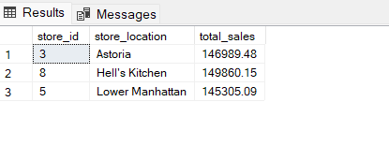

**Insight:** Highlights stores that are overperforming relative to the average sales.

1. **Identify products that make up the top 20% of total sales.**

WITH sales_data AS (

SELECT product_id,

product_detail,

SUM(transaction_qty * unit_price) AS product_sales,

NTILE(5) OVER (ORDER BY SUM(transaction_qty * unit_price) DESC) AS sales_quintile

FROM Transactions

GROUP BY product_id, product_detail

)

SELECT product_id,

product_detail,

product_sales

FROM sales_data

WHERE sales_quintile = 1;

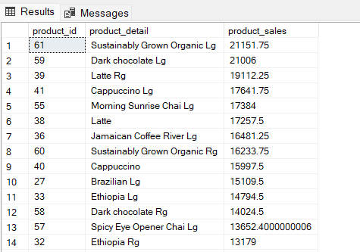

**Insight:** Lists high-performing products by sales, focusing on those that contribute significantly to revenue.

1. **Analyze month-over-month growth % for each product category.**

SELECT product_category,

DATEPART(YEAR, transaction_date) AS year,

DATEPART(MONTH, transaction_date) AS month,

SUM(transaction_qty * unit_price) AS monthly_sales,

LAG(SUM(transaction_qty * unit_price)) OVER (PARTITION BY product_category ORDER BY DATEPART(YEAR, transaction_date), DATEPART(MONTH, transaction_date)) AS previous_month_sales,

(FORMAT(

(SUM(transaction_qty * unit_price) - LAG(SUM(transaction_qty * unit_price)) OVER (PARTITION BY product_category ORDER BY DATEPART(YEAR, transaction_date), DATEPART(MONTH, transaction_date)))

/ NULLIF(LAG(SUM(transaction_qty * unit_price)) OVER (PARTITION BY product_category ORDER BY DATEPART(YEAR, transaction_date), DATEPART(MONTH, transaction_date)), 0) * 100,

'N2'

) + '%' ) AS month_over_month_growth

FROM Transactions

GROUP BY product_category, DATEPART(YEAR, transaction_date), DATEPART(MONTH, transaction_date)

ORDER BY product_category, year, month;

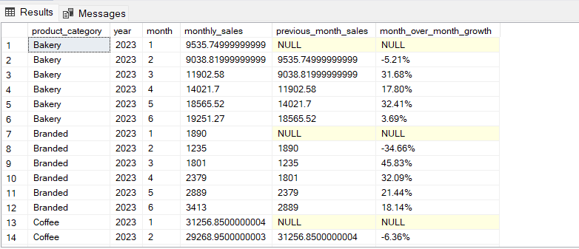

**Insight:** Measures growth trends for each category month-over-month, revealing patterns in product demand.

1. **Find Products Performing Above Average in Specific Stores.**

WITH ProductAvgRevenue AS (

SELECT product_id,

product_detail,

Round(AVG(transaction_qty * unit_price),2) AS avg_product_revenue

FROM Transactions

GROUP BY product_id, product_detail

)

SELECT t.store_id,

t.store_location,

t.product_id,

t.product_detail,

Round(SUM(t.transaction_qty * t.unit_price),2) AS store_product_revenue,

par.avg_product_revenue

FROM Transactions t

JOIN ProductAvgRevenue par ON t.product_id = par.product_id

GROUP BY t.store_id, t.store_location, t.product_id, t.product_detail, par.avg_product_revenue

HAVING Round(SUM(t.transaction_qty * t.unit_price),2) > par.avg_product_revenue

ORDER BY t.store_id, store_product_revenue DESC;

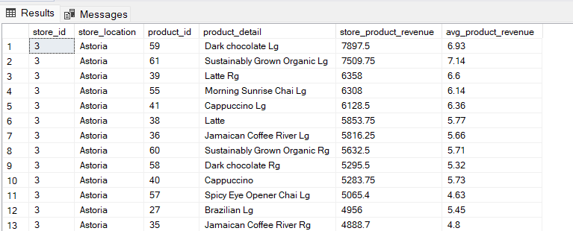

**Insights:** This query helps identify product strengths at the store level and can guide targeted inventory decisions or promotions.